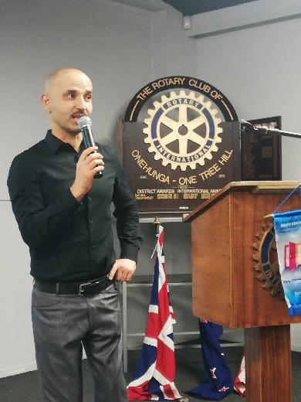
Guest Speaker Rod re-introduced Karim Rostami, who spoke once before about his successful campaign to raise money for charities through long distance swimming. This talk would be his amazing accomplishment since then.
Karim grew up in Afghanistan where at age two he developed Polio, which has left him unable to use his legs properly. Entering New Zealand as a refugee, he has faced many challenges but has managed to own a successful café at the end of Point Chevalier Road.
His exploits as a long distance swimmer started with a swim across the Waitemata to raise money for Surf Lifesaving. Because of his disability, which prevents him from using his legs to swim, he was able to gain enough publicity to raise $97,000 for the cause. He next decided to swim from Waiheke to Auckland, thereby gaining more publicity and raising more funds.
Next task was to do an Iron Man. When asked how he could possibly do this, his answer was “I don’t know”.
When asked why, the answer was “to inspire others”.
Unable to properly run or to ride a bike, he crossed the line as last person counted just inside the cutoff time!. His inspiration raised $46,000 for Polio Eradication.
he was invited into a “crazy idea” of swimming the 100 kilometers between Great Barrier Island and Takapuna with 5 legends of sport.
The 3 hour boat trip gave a chilling reminder of how far this was. The day of the swim was marked by 22 knot winds and a 2 ½ meter swell but the swimmers were not deterred. They were also blessed with sightings of dolphins and whales. Swimming at night was not only calmer but beautifully marked by phosphorus blooms. Daybreak saw Takapuna in sight but the tide was against them and it was a very long time before they reached the beach.
The $360,000 raised bought St Johns two new ambulances.
His next challenge is to swim Cook Straight, with the recipient for the funds raised yet to be announced.
Karim has plans now to achieve the “Oceans 7” around the world.

Duncan thanked Karim for his presentation.

